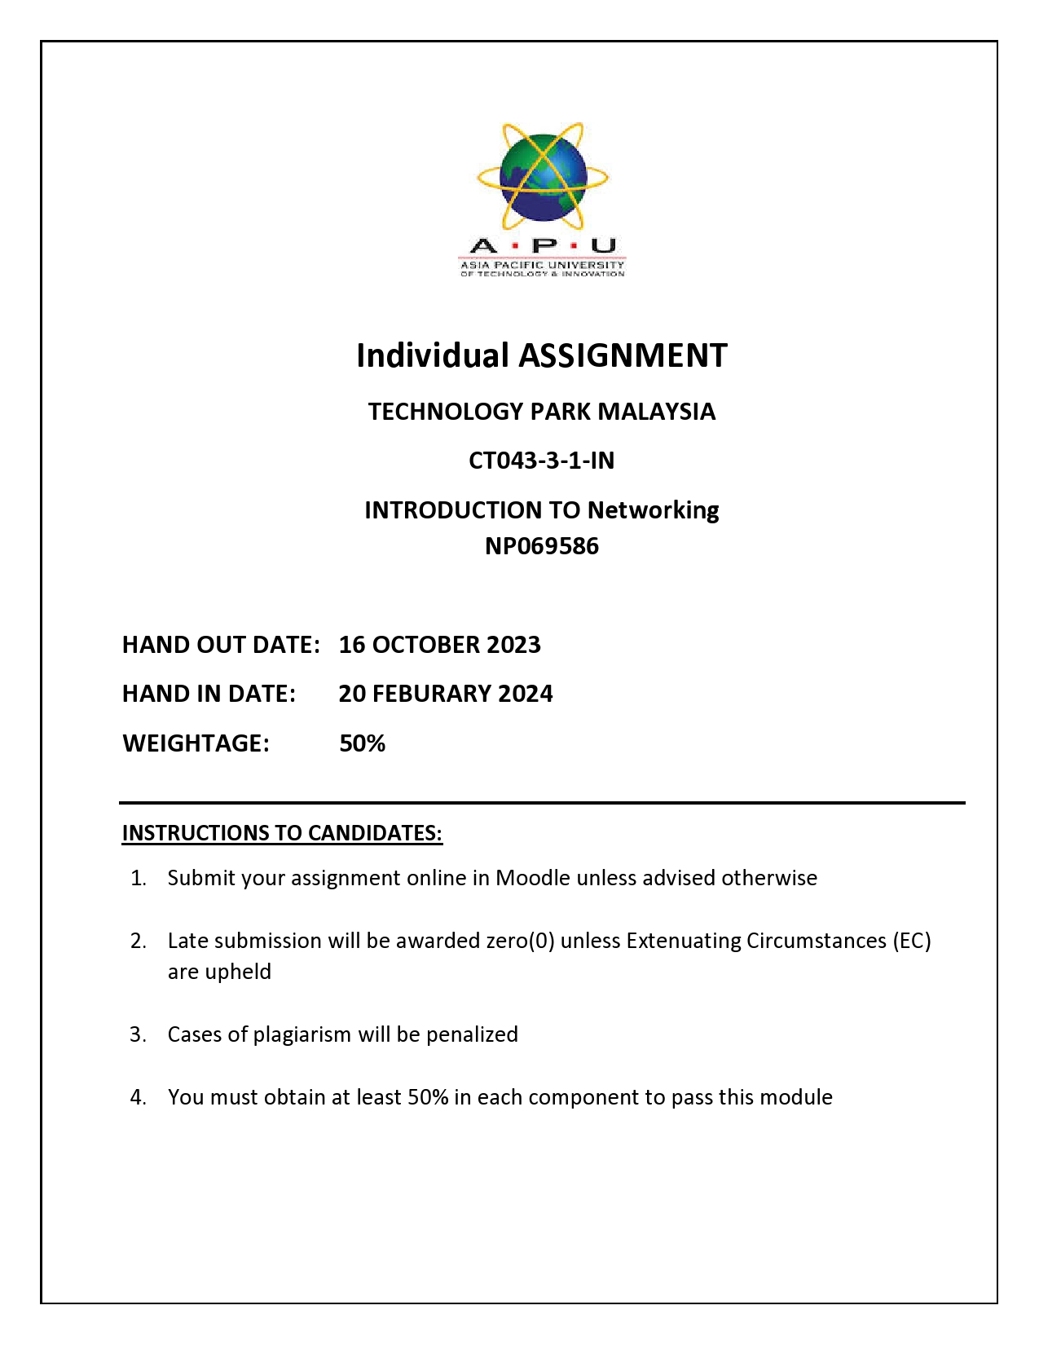

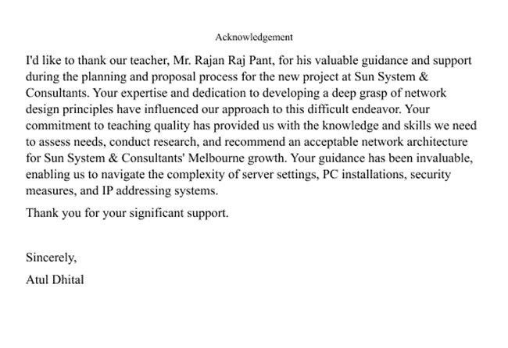

Contents

Introduction: 5

R&D Department: 6

Development and Test Center: 7

Business Analysis Office 7

Server Room & Technical Support Department 8

Justification of Devices use: 10

Configuration and Demonstration 10

Image 11

Conclusion: 11

**Table Of figure**

Figure: Floorplan-Design

Figure I: Development and Testing Department 7

Figure II : R&D Department 8

Figure III: Server Room 8

Figure IV: Conference Room 9

Figure V : Network Design 10

# Introduction:

Sun System & Consultants is a well-versed IT service-providing company and they are expanding branch in Melbourne with the building Harper and Cacis having two floors in each and the following is the Cacis Building second floor.

A network is a group of two or more computers that are linked together to share resources (such as printers or CDs), exchange files, and facilitate electronic communication. Computers on a network can communicate with one another via cables, telephone lines, radio waves, satellites, or infrared laser beams. (fcit.usf.edu/, n.d.)

**Floor plan Cacis Building Second Floor**



Fig: Cacis 2nd floor design

As a network designer I need to insure all the devices need to work properly and manage all the room as the floor plan requirement of Cacis Building Second Floor.

The Cacis building's second level contains seven rooms, including an employee break area where staff may rest, a research and development department that focuses on ERP system development, and a test and laboratory room.

A development system that works with the R&D department, a server room that is the heart of network management, a technical assistant room that handles all technical needs, a business analyst department that evaluates and improves each department's performance, and a large group and meeting room. The conference room is available. Our firm employs a PC and has a decent office environment; each department is equipped with a VoIP (Voice over Internet Telephone) for intercommunication and network-connected printers.

In the staff rest are they can rest inside the room also we have bed and firstaid if any staff get health emergency. This floor has key areas including business analyst, development and testing, technical assistant, conference, and server rooms, all with high-speed computers for optimal performance and comfort. We also have CCTV and hallway security to safeguard the safety of our employees and operations, and all units are linked to a master switch that connects to the main router on the floor. The Brother trademark is used for a variety of electronic equipment, including printers and scanners. The staff break area has an LG TV for amusement, and WiFi has been provided for satellite TV. The Technical Assistant Room has a computer workstation, video surveillance, a scanner, a printer, and a sofa. The Research and Development Department consists of seven computers for staff. The conference includes a projector, computers, and a wide conference table for presenting and discussing work. The server room has three office servers and one server with additional business PCs. The staff bathroom has Wi-Fi, and a small table where employees may take a rest.”

# R&D Department:



Figure R&D Department

# Development and Test Center:



Figure 1Development and Testing Department

# Business Analysis Office



Figure II

# Server Room: Technical Support Department

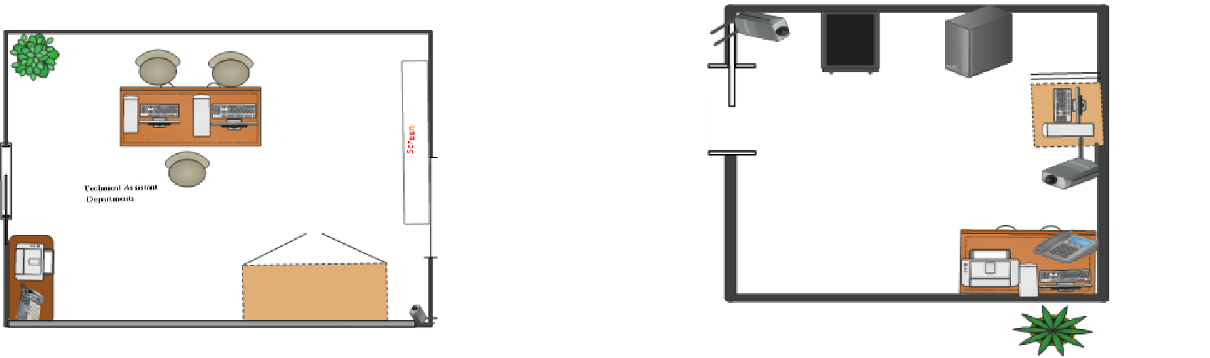

Figure III

**Employee Rest Area**   **Conference room:**



Figure IV

**Network Design Cacis Building Second Floor**

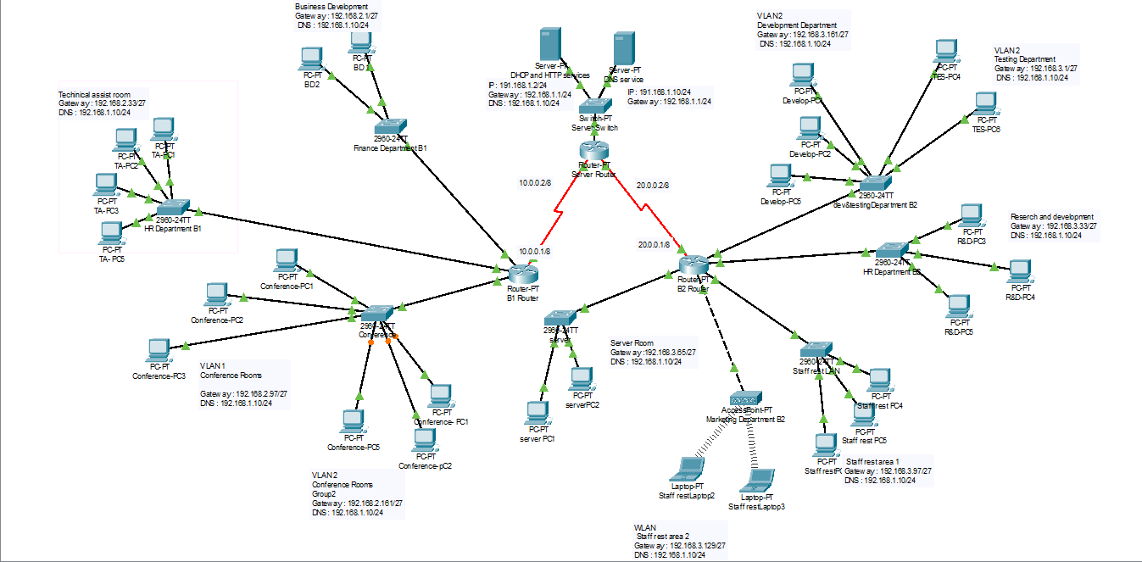

Figure V

# Justification of Devices use:

Router: A router is a device that connects two or more packet-switched networks or subnetworks (cloudflare, n.d.) . I used cisco router because it is easy to configure and less cost.

Switch: A network switch connects devices in a network to each other, enabling them to talk by exchanging data packets. Switches can be hardware devices that manage physical networks or software-based virtual devices (techtarget.com, n.d.). I use cisco Switch 2900 series because This switch is easy to configure and less cost.

DHCP Server: A DHCP Server is a network server that automatically provides and assigns IP addresses, default gateways and other network parameters to client devices. It relies on the standard protocol known as Dynamic Host Configuration Protocol or DHCP to respond to broadcast queries by clients (infoblox.com, n.d.).

# Configuration and Demonstration

|  |  |  |  |
| --- | --- | --- | --- |
| S.N | Test Type | Description | Image |
| 1 | Internal Test | From R&D Department 192.168.2.1 to Server Room 192.168.3.66 |  |
| 2 | Internal Test | From Server room to  Development And Testing |  |
| 3 | Internal Test | From server to Staff rest area |  |

# Conclusion:

This group project allowed me to learn about how IP works, how to work effectively in a group, how to make a floor plan, which was important for developing a networking concept, and how each IP communicates with one another via IP configuration.

# Bibliography

cloudflare, n.d. *cloudflare.* [Online]   
Available at: https://www.cloudflare.com/learning/network-layer/what-is-a-router/

fcit.usf.edu/, n.d. *fcit.usf.edu.* [Online]   
Available at: https://fcit.usf.edu/network/chap1/chap1.htm

infoblox.com, n.d. *What is DHCP Server?.* [Online]   
Available at: https://www.infoblox.com/glossary/dhcp-server/#:~:text=A%20DHCP%20Server%20is%20a,to%20broadcast%20queries%20by%20clients.

skfdjskdfjs, n.d. *sdfsdf.* [Online]   
[Accessed 2014].

techtarget.com, n.d. *What is a network switch?.* [Online]   
Available at: https://www.techtarget.com/searchnetworking/definition/switch

xgxdfd, n.d. *xxfdxd.* [Online]   
[Accessed 2010].